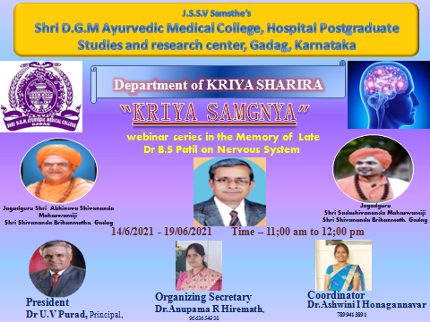

The dept of Kriya Sharira has organised a Webinar Series on Nervous system “KRIYA SMGNYA” in the memory of late Dr.B.S Patil sir, on Date-14-06-2021 to 19/06/2021 at 11am-12:00pm with a targeted group 1st year BAMS students and Institution faculty.
Aim –
Enhancing the Knowledge of Nervous System with its applied aspect to 1st year BAMS students
Objective –
At the end of this webinar series each student should be able to,
  - Know, Basics of Nervous System
  - Apply the clinical aspects of CNS,ANS,PNS
  - Illustrate Suitable examples for each concept in Nervous system

Protocol of Webinar series
- Welcoming the Guest
- Inauguration by Lightening the Lamp
- Dhanwantari Sthavana
- Keynote Adress – By Dr. Anupama R Hiremath, HOD and Associate professor, Department .of Kriya sharira, DGM Ayurvedic Medical College andHospital,Gadag
- Inaugural Guest Speech – By Dr. Mahendra Director, Prasaranga, RGUHS,Banglore
- Presidential Speech – Dr. U.V Purad Principal, DGM Ayurvedic Medical College and Hospital,Gadag
- Vote Of Thanks : Dr.Ashwini I Honagannavar, Assistant Professor, Department of Kriya sharira,DGM Ayurvedic Medical College andHospital,Gadag.
- Webinar Sessions start @ 11am
Inauguration Started at 11am with the blessing ofShri Jagadguru Shri Abhinava Shivanada mahaswamiji, and Jagadguru Shri Sadashivanada Mahaswamijiof Shri Shivanada Brihanmath Gadag, by lightening the Lamp and offering flowers to Lord Dhanwantari and late Dr.B S Patil sir.
Dhanwantari Sthavana is Chanted by 1st year Faculty and Webinar series is inaugurated by Dr. Mahendra B J Director, Prasaranga, RGUHS,Banglore,in presence of President Dr.U.V Purad,Principal,DGM Ayurvedic Medical College andHospital,Gadag and Organizing Secretary Dr.Anupama R Hiremath, HOD and Associate professor, and Coordinator Dr.Ashwini I Honagannavar, Assistant Professor, Department .of Kriya sharira.
Dr.Mahendra sir explained that research, Conceptual and analytical articles in Ayurveda Field in different topics should be published.Dr.U.V Purad sir has given Presidential speech on how to develop skills in examination of nervous system in present era. Finally Dr.Ashwini Honagannavar, madam has given Vote of Thanks.

1st Session of Webinar series – Dr. Rajashri R
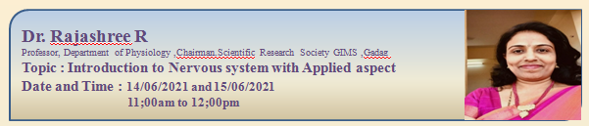
Topic - Introduction to Central Nervous system with Applied aspect
Date and Time – 14/06/2021, 11am-12pm
Topic - Sympathetic and parasympathetic nervous system with suitable examples along with applied aspect.
Date and Time – 15/06/2021, 11am-12pm

2nd Session of Webinar series – Dr.Citra Gawande
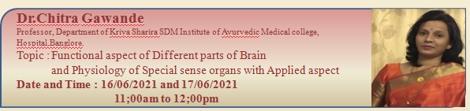
Topic - Functional aspect of Different parts of Brain
Date and Time – 16/06/2021, 11am-12pm
Topic - Physiology of Special sense organs with Applied aspect
Date and Time – 17/06/2021, 11am-12pm

3rdSession of Webinar series – Dr.Somanath Ginni
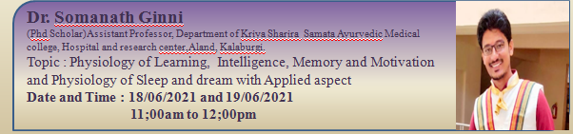
Topic - Physiology of Learning, Intelligence, Memory and Motivation
Date and Time – 18/06/2021, 11am-12pm
Topic - Physiology of Sleep and dream with Applied aspect.
Date and Time – 19/06/2021, 11am-12pm

Valedictory
Valedictory Started at 12;15pm in presence of Valedictory Chief Guest Dr Neha Dattatraya Gadgil, Associate Professor, Department of Kriya sharira, Parul Institute of Ayurveda, Limda, Waghodia, vadodara, Gujarat, Dr.U.V Purad,Principal,DGM Ayurvedic Medical College andHospital,Gadag and Organizing Secretary Dr.Anupama R Hiremath, HOD and Associate professor, and Coordinator Dr.Ashwini I Honagannavar, Assistant Professor, Department .of Kriya sharira.
Dr.Neha madam explained How we can correlate some of Ayurvedic concept with modern correlation and also taught with examples like process of defecation in Ayurveda. Dr.Chitra Gawande madam,Dr Somanath Ginni sir Given overview on Webinar series on Nervous System. Mahesh and Asha students given opinion on how this webinar series on nervous system help them to improve their knowledge. Finally Dr.Anupama Hiremath Madam given Vote of Thanks and whole webinar series was Conducted by Dr.Ashwini Honagannavar.Valedictory ended at 1;15pm

